Dushyant Sutariya

Email ID: vkdsutariya@gmail.com, mob. No.-9723997829,9726837883

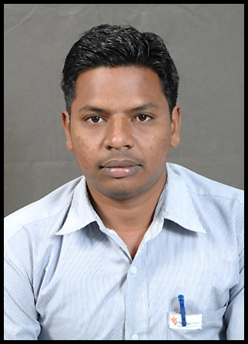

OBJECTIVE

Seeking a Challenging position in Manufacturing Industries.
Desire Professional growth based on performance and accomplishment for betterment.

SNAP SHOTS
- Maintenance & Production department as a Mechanical Engineer.
- A quick learner with positive attitude and ability to work in a team environment.
- A keen communicator with an ability to relate to people across all hierarchical levels in the organization. Possess ability to motivate people to achieve organizational objectives.

ORGANISATIONAL EXPERIENCE

- 5th SEPT 12-TILL NOW.

(PGP GLASS LTD, Jambusar)

- Have an experience in IS Machine maintenance, breakdown & preventive maintenance, implementing lean manufacturing tools likewise 5S, Kaizen, cost saving, waste elimination, why why analysis, framed within our ‘parivartan’ board.
- Have been handling manpower effectively and in an optimized manner.
- Have been thoroughly working with the flacconages machineries and regular job change activity.
- Have been using SAP from enrolling the MM modules and PM modules,
- Have been involved with ISO standards and have a bit of knowledge regarding it.
- Maintaining & monitoring of various parameters.
- Adjusting & Controlling Process Equipments.
- Start up & Shut Down of the Plant.
- Trouble shooting in the Plant.
- Knowledge of centrifugal and reciprocating pump & compressor, rotary equipment, conveyor, blower, gear box, mechanical seal & fabrication work.
- Coordinating work with supervisor & company worker, labors.
- Coordinating Maintenance job with Electrical Mechanical & Instrument Engineers.
- Fire & Safety, Housekeeping, etc.,
- Handling of all operation carefully with safety standards & as per SOP
- Reporting to HOD power consumption valuation, Housekeeping, Manpower Handling, Handling process on PLC system, Energy consumption, Handling of different process related activities, different operations, under vacuum Exothermic/Endothermic Reaction.
- Involved in production planning, evaluating engineering work & energy efficiency.

Compensation------

POST—Assistant Manager

C.T.C— 9,00,000 RS. (PER ANNUM)

DEPARTMENT—IS MAINTENANCE

ACADEMIC CREDENTIALS
- S.S.C- 73.57%.
- Diploma in Mechanic Eng- 66% (First class)
- Auto cad.
- Computer operator programmer assistant.
- SAP MM module and PM module.

ADDITIONAL CERTIFICATE
- Parivartan auditor certificate.
- Kaizen certificate.
- Six sigma (Green belt)
- IMS Auditor
SKILLS AQUIRED

Operating Systems : MS – DOS, WINDOWS 98, XP.
Word Processor : MS – Word
Electronic Spreadsheet : MS – Excel
Publishing Tools : MS – Power Point
Others : Internet, E-Mail

PERSONAL DETAILS

Name : Sutariya Dushyant
Permanent Address : B/398, Suryadarshan Township,
Manjalpur, Baroda
Contact No : +91 9723997829,6351947134
Date of Birth : 05/05/1988
Father’s Name : Shivabhai
Marital Status : married

(Dushyant S.)

